***Cooling Tower***

* **Title:**

Find the effectiveness of cooling tower:

* **Introduction:**

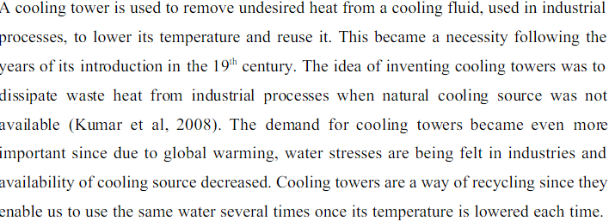

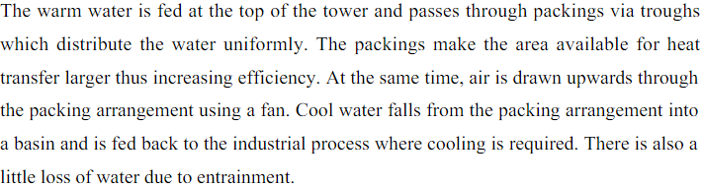

* **Parts list:**
* Cooling water basin
* Fills
* Water distribution pipings
* Cooling tower fans
* Cooling tower structure
* Drift eliminator
* **Fills:**

Cooling Tower Fill is the main heat transfer area available for Heat transfer from Hot water to Cold Air. There are two types of fills available namely Splash fills & Film Fills. Splash fills disintegrates the hot water from vertical direction and it splits the water to pass through next level of splash bars. Film fills forms thin vertical film of water to make the air to contact in with to aid heat transfer. Fills are normally made of PVC, Polypropylene or Wood.

* **Cooling water basin:**

Cold Water Basin is normally made up of Reinforced Cement Concrete (RCC). It has got two functions. One is to collect the cold water from tower and acts as storage. The other is being strong it acts as a foundation for the main structure of cooling tower. The cold basin is either lies on the top of the soil or lies below the ground level. The height of the cooling tower is determined from the distance between the top of the cold basin to fan assembly.

* **Water distribution pipings:**

Cooling Water Distributing pipes to hot basin must be buried underground or supported in ground to avoid thrust loading of the tower due to self weight and water pressure inside the pipe. Individual cell inlet piping is to be independently supported.

* **Cooling Tower Fans:**

Main part of the cooling tower components. Cooling Tower fans are normally made from Aluminum, Fiber Reinforced Plastic (FRP), Glass fiber and hot-dipped galvanized steel are commonly used as fan materials. FRP being light in weight, impellers made up of FRP reduces the power requirements of the fan. Cooling tower fan blades pitch angle is varied depending on seasonal requirements.Cooling tower Fan blade Pitch angle is the angle made by the fan with the plane. Normally during summer season the air density is low. So the fan blade pitch angle is increased to increase the capacity of the fan.

* **Cooling Tower Structure:**

Most of the Towers are made up of Chemically Treated Wood, while RCC & Fiber Reinforced Plastic (FRP) cooling towers are also available depending on the requirement of the user.

* **Drift Eliminators:**

The purpose of Drift eliminator is to reduce the drift loss in cooling tower. Drift eliminators normally kept next to fills in the air flow path thereby reducing the drift loss. Drift loss is the loss of entrained water through hot air to atmosphere. Drift eliminators normally made up of PVC. More number of passes through drift eliminator decreases the drift loss but increases the pressure drop thereby increasing fan power consumption.

* **Cooling Tower components – Louvers:**

Louvers are made up of asbestos sheets. It serves two purposes. One is to retain circulating water within the tower, and other is to equally distribute the air flow into the fill.

* **Types of cooling tower:**
* Cross flow cooling tower
* Counter flow cooling tower
* Hyperbolic cooling tower
* Induced draft cooling tower
* Passive draft cooling tower
* **Crossflow cooling towers:**

Cross flow cooling towers use a splash fill that allows in-flowing to air move in a horizontal path over the stream of water from the upper reservoirs. Cross flow systems are some of the more expensive equipment types, but they are also some of the easiest to maintain. However, these cooling systems are more vulnerable to frost than others.

## Counter flow cooling towers:

In a counter flow system, the in-flowing air travels in a vertical path over the splash fill as the water streams down from the reservoir above. Counter flow systems are usually smaller than their cross flow counterparts. These cooling towers are more expensive due to the fact that more energy is needed to push the air upward against the down-flowing water.

## Hyperbolic cooling towers:

Hyperbolic systems are well-built and require a minimal amount of resources. Though they require few resources, these cooling towers are able to efficiently manage large-scale tasks within big chemical or power plants.

Hyperbolic systems use a chimney stacking technique that allows the cooler, outside air to push the damp, warmer air inside the tower. Splash fill is placed around the bottom of the tower and the water that sprays over it is cooled by the passage of upward-flowing air.

## Induced draft cooling towers:

Induced draft or mechanical draft cooling towers use some type of mechanical pressure like a fan system, to push air upward inside the tower. Induced draft systems can also force air into the tower with a blow-through or pull it out through a draw-through.

## Passive draft cooling towers:

Passive or natural draft cooling towers combine the upward motion of warmed air with a steep chimney architecture to organically pull air throughout the tower. Although passive draft systems may have either a counter or cross flow transport design, hyperbolic towers are always passive draft.

* **Table of readings:**

**WATER SPEED=5.6 WATER SPEED=7.6**

|  |  |  |  |  |  |
| --- | --- | --- | --- | --- | --- |
| **Flow** | **T1** | **13** | **FLOW** | **T1** | **14** |
| **R** | **T2** | **13** | **R** | **T2** | **14** |
| **A** | **T3** | **14** | **A** | **T3** | **15** |
| **T** | **T4** | **15** | **T** | **T4** | **16** |
| **E** | **T5** | **15** | **E** | **T5** | **17** |
| **=4** | **T6** | **13** | **=7** | **T6** | **15** |
|  | **T7** | **12** |  | **T7** | **13** |

* **CALCULATIONS:**

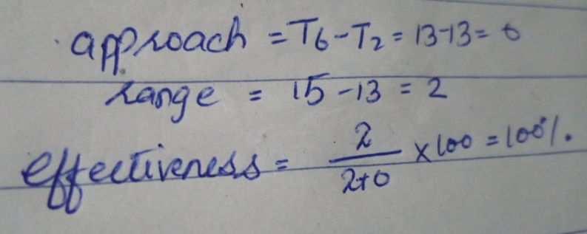

For graph 2:

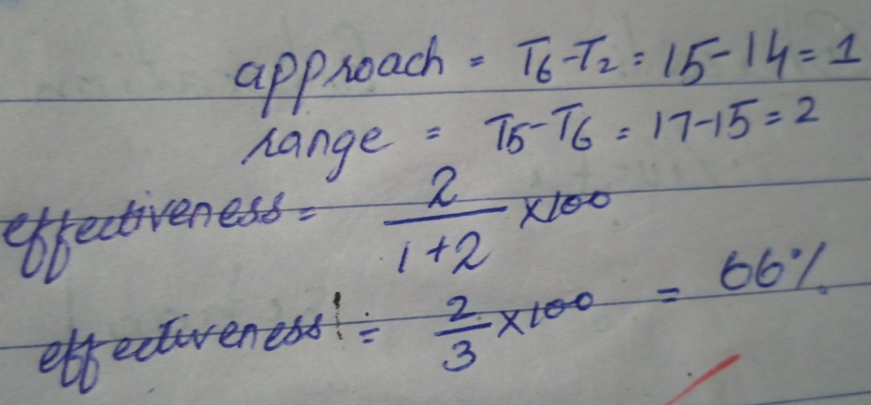

* **Applications:**

Cooling tower is used in industries where we have to remove heat with the help of cool water.

It is also used in homes to obtain cool water.

It is also used in offices.